

Capstone project -university success analysis

NITHYA K



University success ANALYSIS

---

NITHYA K

**OBJECTIVE**

This project analyses university rankings across different ranking systems to understand the factors influencing university performance. It leverages six datasets covering universities, ranking criteria, ranking systems, and country-level details. The analysis focuses on university demographics, ranking trends, and performance indicators using SQL, Power BI, and Excel. The project follows a structured approach to explore the correlation between student metrics and ranking scores, differences in ranking methodologies, and the distribution of top-ranked universities worldwide.

**THE PROCESS**

1. **Data Acquisition from GitHub**

The project began with data acquisition from GitHub, where both SQL files and CSV files were downloaded. The SQL files contained structured relational data for universities, ranking systems, ranking criteria, and country information, while the CSV files provided additional data on university rankings and student demographics.

1. **Data Transformation**

Data cleaning is a crucial step in the data preparation process, ensuring high-quality and accurate data for analysis. In this phase, I address various anomalies and inconsistencies to enhance data reliability. Data deduplication eliminates duplicate records that may skew results, while outlier detection and treatment mitigate extreme values that could distort findings. Noise reduction techniques smooth or filter noisy data points to minimize errors.

Data type conversion ensures consistency and suitability for analysis, while case standardization and whitespace trimming correct formatting issues. Spell checking helps rectify typographical errors, and managing null and zero values prevents analytical biases. Additionally, resolving inconsistent data, rounding numerical values appropriately, and eliminating redundant or irrelevant data improve dataset integrity.

Finally, code mapping assigns meaningful labels to categorical codes, and statistical analysis with linearity assessment helps detect patterns and anomalies. These steps collectively enhance the dataset's accuracy and reliability, leading to more precise and insightful analysis.

1. **ECE Breakdown of University Success Analysis**

* **University Analysis** – Examines university distribution, student demographics, international student percentage, and faculty availability. Analyses trends in enrolments and student-staff ratios.
* **Ranking System Analysis** – Compares different ranking systems, evaluates ranking criteria, assesses the number of universities ranked, and examines ranking consistency.
* **Performance Analysis** – Investigates the relationship between ranking scores, student-staff ratio, research output, and international student impact. Analyses ranking trends and financial support metrics.
* **Country-Level Analysis** – Studies the number of ranked universities per country, the impact of policies on rankings, international student mobility trends, and leading countries in global rankings.

1. **Data Integration & Connection with Tools**

• The **CSV files** were imported into **Power BI**, enabling dynamic visualization and advanced calculations using **DAX functions**.

• SQL queries were written to explore **Exploratory Data Analysis (EDA) questions**, allowing for structured insights into university rankings.

• **New tables for Population and GDP** were created in SQL to supplement the analysis, providing additional insights into country-level trends.

1. **Power BI Analysis**

• Addressed **19 problem statements** related to university rankings, student demographics, and ranking system methodologies using Power BI.

• Implemented **DAX functions** for advanced calculations, ranking comparisons, and trend analysis.

• Created measures and calculated columns to derive meaningful insights.

* **Country-Level Analysis** – Examining university rankings and performance by country.
* **Performance Analysis** – Understanding trends in student numbers, faculty ratios, and ranking performance over time.
* **Ranking System Analysis** – Comparing different ranking systems and their impact on university rankings.
* **University Analysis** – Evaluating individual university performance based on rankings and demographic factors.

1. **Exploratory Data Analysis (EDA)**

• **SQL queries** were used to answer **15 EDA questions** related to university rankings, international student distribution, student-staff ratios, and ranking trends.

• The query results were exported and **analysed in Excel** using pivot tables and charts to derive insights.

1. **Report Creation & Insights**

• Designed PowerPoint presentations with charts, graphs, and key findings from Power BI and Excel.

• Included insights explaining ranking trends, country-wise university performance, and ranking system differences.

1. **Detailed Documentation**

* Compiled a structured document covering the project objectives, methodology, SQL queries, Power BI analysis, and key takeaways for future reference and stakeholder presentations.

**OBJECTIVE**

The primary objective of this project is to conduct an in-depth analysis of global university rankings by examining key performance indicators, ranking methodologies, and institutional characteristics. This project aims to uncover insights into the factors that influence university rankings, such as student demographics, faculty-to-student ratios, international student representation, and ranking criteria applied by different ranking systems.

By leveraging structured datasets, SQL queries for exploratory data analysis (EDA), Power BI for data visualization, and Excel for additional analysis, this project seeks to:

1. **Understand University Performance**

• Analyse the distribution of universities across different countries and identify global trends in higher education.

• Examine the correlation between university rankings and factors such as student-staff ratios, international student percentages, and female student representation.

• Track year-over-year changes in university performance and identify patterns over time.

1. **Evaluate Ranking System Methodology**

• Compare different ranking systems (e.g., QS, Times Higher Education) to understand variations in scoring criteria

• Assess how ranking systems prioritize academic reputation, research output, employability, and other criteria.

• Determine the impact of ranking methodologies on university scores and positioning.

1. **Analyse Country-Level Trends**

• Identify the top-performing countries in terms of university rankings and analyse regional differences.

• Assess the impact of economic factors such as GDP and population on university rankings.

• Investigate how country-level policies and investments in education affect university performance.

1. **Provide Actionable Insights for Stakeholder**

• Help universities identify areas for improvement to enhance their global rankings.

• Assist policymakers in understanding how education policies impact higher education performance.

• Enable students to make informed decisions when selecting universities based on rankings and performance metrics.

By structuring the analysis into four key areas—University Analysis, Ranking System Analysis, Performance Analysis, and Country-Level Analysis—this project ensures a comprehensive evaluation of university rankings. The insights derived will serve as valuable information for academic institutions, education policymakers, researchers, and students aiming to understand and improve university performance in a global context.

**SIGNIFICANCE**

University rankings play a crucial role in shaping the reputation, funding, and student enrolment of higher education institutions worldwide. This project aims to analyse university rankings and related factors using SQL, Excel, and Power BI to uncover meaningful insights. By leveraging ELT techniques, data modelling, and visualization, the project provides a comprehensive understanding of how universities perform across different ranking systems and criteria. It explores key relationships between ranking scores, international student percentages, student-staff ratios, and other essential metrics. The findings from this analysis can assist universities, policymakers, and students in making data-driven decisions regarding institutional improvements, global competitiveness, and student preferences. Moreover, the project demonstrates the power of data analytics in higher education, showcasing how structured data can be transformed into actionable insights to enhance university performance and ranking strategies.

**DATA DICTIONORY**

**University ranking year:**

Stores yearly university ranking scores based on different ranking criteria.

* + University id – INT → Unique identifier for the university, referencing the University table.
  + Ranking criteria id – INT → Unique identifier for the ranking criterion, referencing the Ranking Criteria table.
  + year – INT → The year in which the ranking was recorded.
  + Score – INT → The score assigned to the university based on the ranking criteria**.**

### **University:**

Contains basic details about universities.

* **id** – INT → Unique identifier for the university.
* **Country id** – INT → Foreign key referencing the **Country** table, indicating the country where the university is located.
* **University name** – STRING → The official name of the university.

**University year:**

Records yearly university statistics related to student demographics and staff ratios.

* **University id** – INT → Foreign key referencing the **University** table.
* **year** – INT → The year in which the data was recorded.
* **Num students** – INT → The total number of students enrolled at the university in a given year.
* **Student staff ratio** – DECIMAL → The ratio of students to academic staff, indicating teaching capacity.
* **Pct international students** – DECIMAL → The percentage of international students enrolled.
* **Pct female students** – DECIMAL → The percentage of female students enrolled.

**Country:**

Stores details about different countries.

* **id** – INT → Unique identifier for each country.
* **Country name** – STRING → The official name of the country.

**Ranking Criteria:**

Defines the criteria used for ranking universities.

* **id** – INT → Unique identifier for the ranking criteria.
* **Ranking system id** – INT → Foreign key referencing the **Ranking System** table, indicating the ranking system associated with the criteria.
* **Criteria name** – STRING → The name of the ranking criteria (e.g., academic reputation, research impact, employability).

**Ranking System:**

Contains information about different university ranking systems.

* **id** – INT → Unique identifier for the ranking system.
* **System name** – STRING → The name of the ranking system (e.g., QS World University Rankings, Times Higher Education).

**ADDED TABLES**

**Population:**

Stores details about different countries Population.

* **Country id** – INT → Unique identifier for each country
* **Population millons** – DECIMAL → The population of each country.

**GDP Data:**

Stores details about different countries GDP.

* **Country id** – INT → Unique identifier for each country
* **GDP** – DECIMAL → The population of each country.

**ER Diagram:**

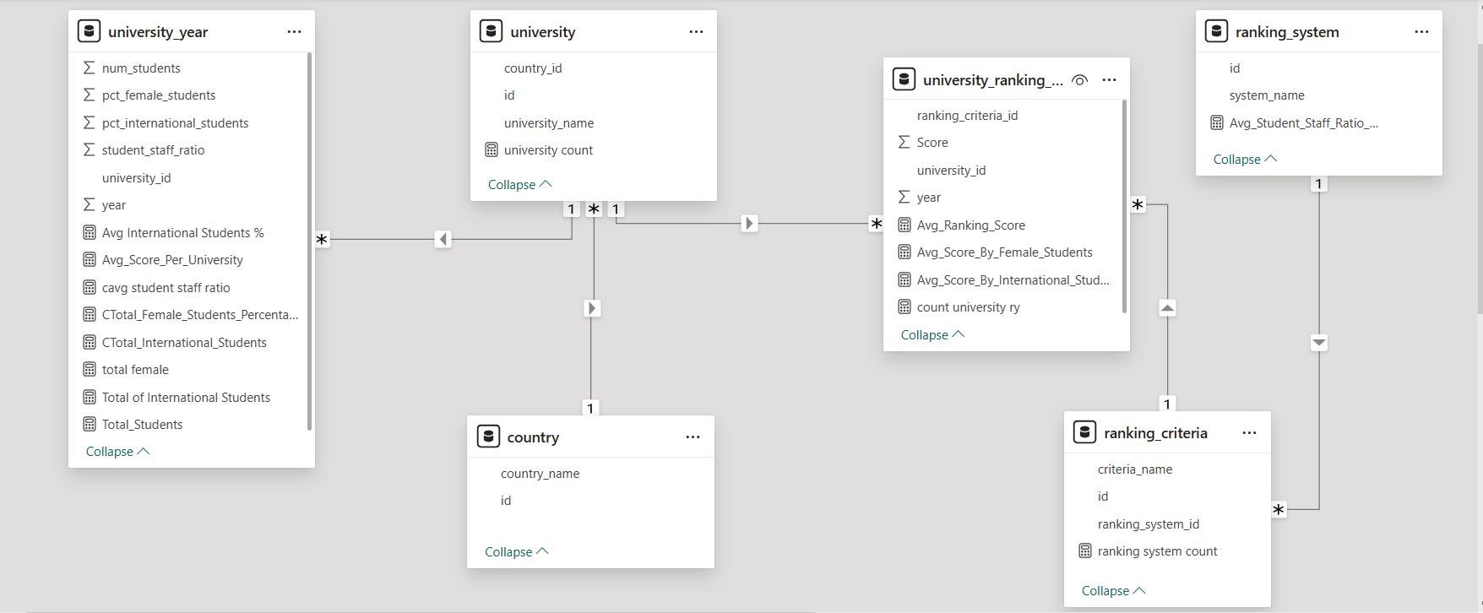

**Simplified ER Diagram:**

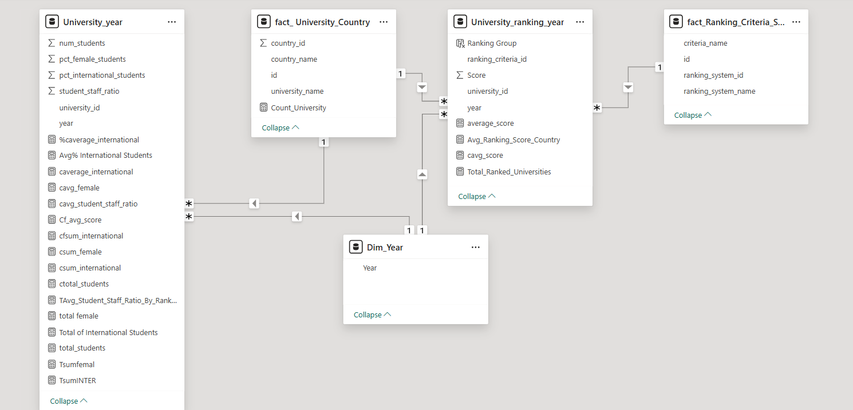

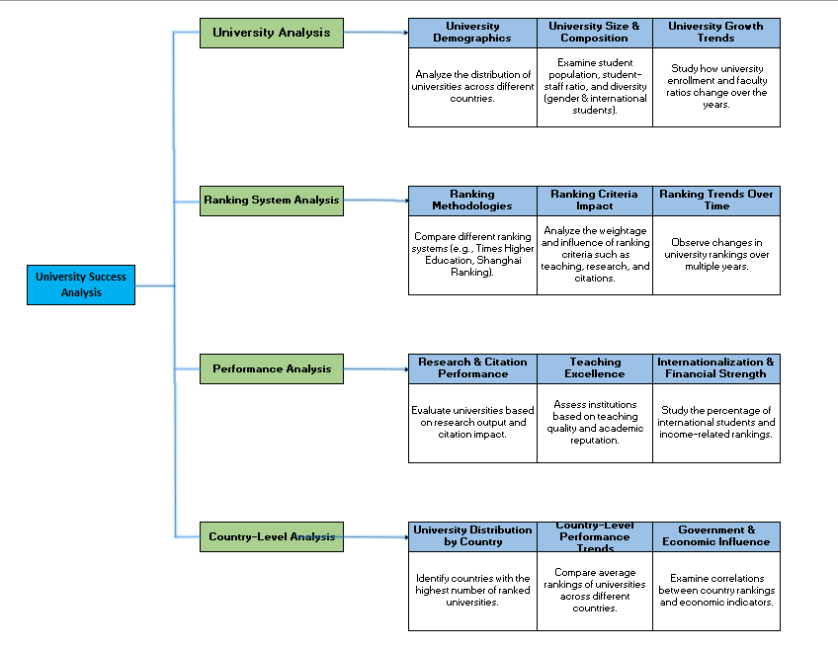**MECE Breakdown**

**1️. University Analysis**

* Examines the number of universities in each country.
* Analyses student distribution, international student percentage, and faculty availability.
* Studies the correlation between student-staff ratio and university success.
* Evaluates changes in university enrolments over time.

**2️. Ranking System Analysis**

* Compares different university ranking systems (e.g., QS, Times Higher Education).
* Assesses the impact of ranking criteria on university performance.
* Examines the number of universities ranked by each system.
* Evaluates ranking consistency across different systems**.**

**3️. Performance Analysis**

* Investigates the relationship between ranking score and student-staff ratio.
* Analyses trends in university rankings over the years.
* Studies the impact of international students on rankings and university performance.
* Evaluates research output, faculty-to-student ratio, and financial support metrics.

**4️. Country-Level Analysis**

* Analyses the number of ranked universities per country.
* Studies the impact of country-specific policies on university rankings.
* Evaluates trends in student mobility and international student attraction.
* Identifies the leading countries in global university rankings.

**Power BI Problem Statements**

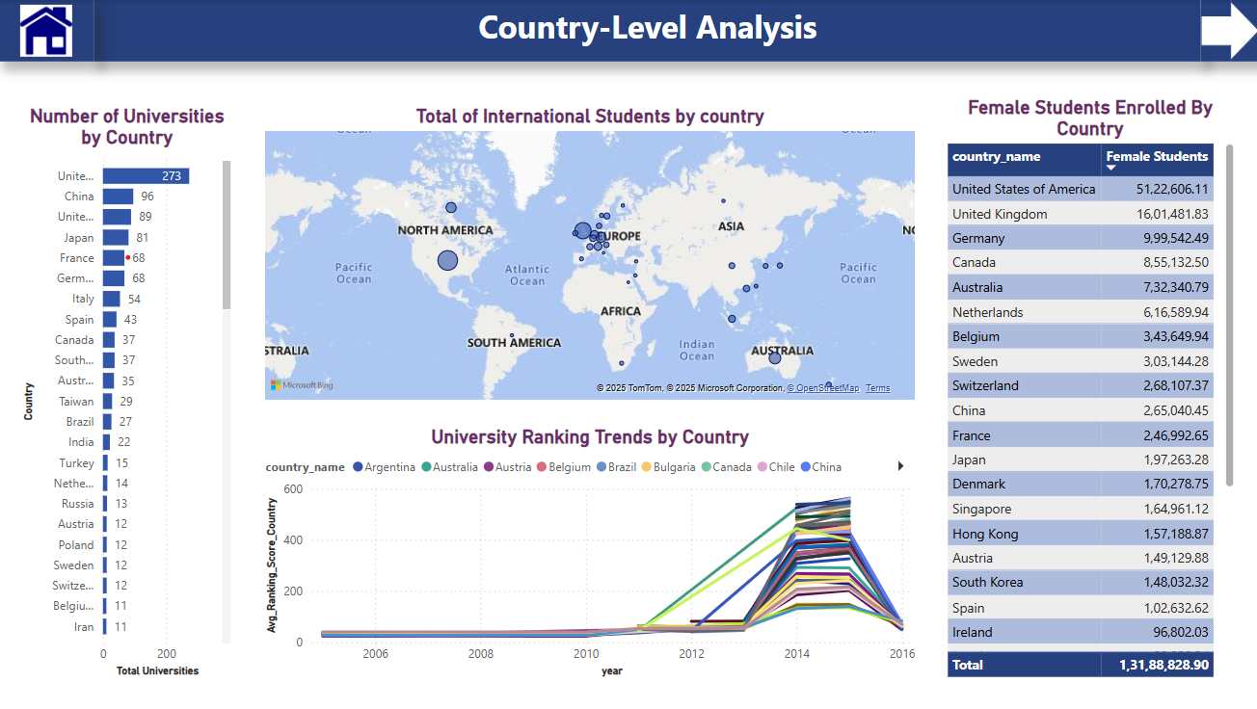

**How many universities are there in each country?**

The analysis of the number of universities by country reveals that the United States leads significantly with 273 universities, followed by China (96) and the United Kingdom (89). Other countries such as Japan, France, and Germany also have a strong presence in higher education. This distribution highlights the dominance of developed nations in global university rankings, with the availability of academic institutions reflecting national investments in higher education and research. The data suggests that countries with a larger number of universities may have more opportunities for higher education but does not necessarily indicate the quality of these institutions.

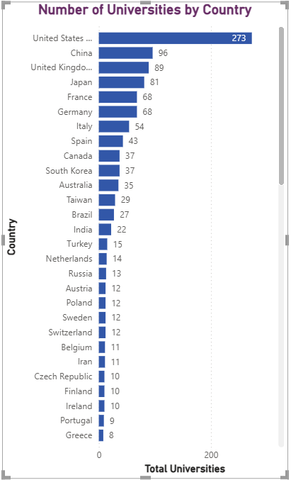

**What is the distribution of international students across different countries?**

The map visualization indicates that North America, Europe, and Australia have the highest concentration of international students, with the U.S., U.K., Canada, Germany, and Australia being the leading destinations. This trend is influenced by factors such as world-class universities, strong research infrastructure, scholarship opportunities, and favorable immigration policies. Emerging destinations in Asia, such as China and Japan, are gaining popularity due to competitive education standards and international collaborations. In contrast, Africa and South America have a comparatively lower number of international students, possibly due to limited global university rankings and fewer international programs. To attract more students, universities in underrepresented regions could focus on enhancing academic reputation, increasing funding for research, and expanding English-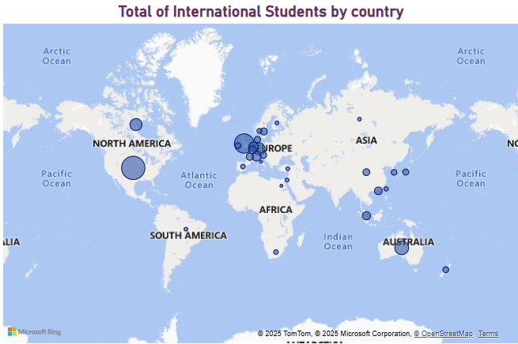language programs.

**Which country has the highest number of female students enrolled in universities?**

The analysis of female student enrolment by country highlights that the United States has the highest number of female students, surpassing 5.1 million. The United Kingdom follows with over 1.6 million, while Germany, Canada, and Australia also report significant female student populations. European countries such as the Netherlands, Belgium, and Sweden contribute notable numbers.

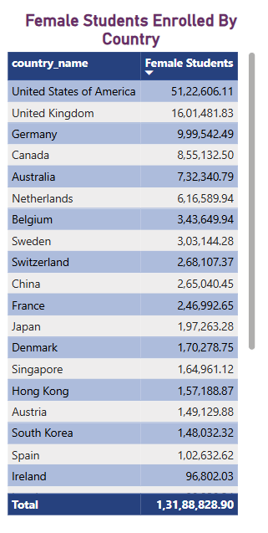

Interestingly, China and Japan, despite having numerous universities, report comparatively lower female student enrolments. The total number of female students across all listed countries exceeds 131 million, emphasizing the growing presence of women in higher education globally. This data reflects gender participation trends and the accessibility of higher education for women in different regions.

**Are there any significant trends or patterns in the rankings of universities from different countries?**

The significant fluctuations in university ranking scores across countries, particularly around 2013–2014, indicate possible changes in ranking methodologies, policy shifts, or increased competition among universities. While some countries show stability, others experience drastic variations, suggesting the need for universities to adapt to evolving ranking criteria. To improve rankings, institutions should focus on consistent academic excellence, research output, faculty-student ratios, and global engagement. Policymakers should also ensure alignment with international standards to enhance global competitiveness and sustain long-term improvements in university rankings.

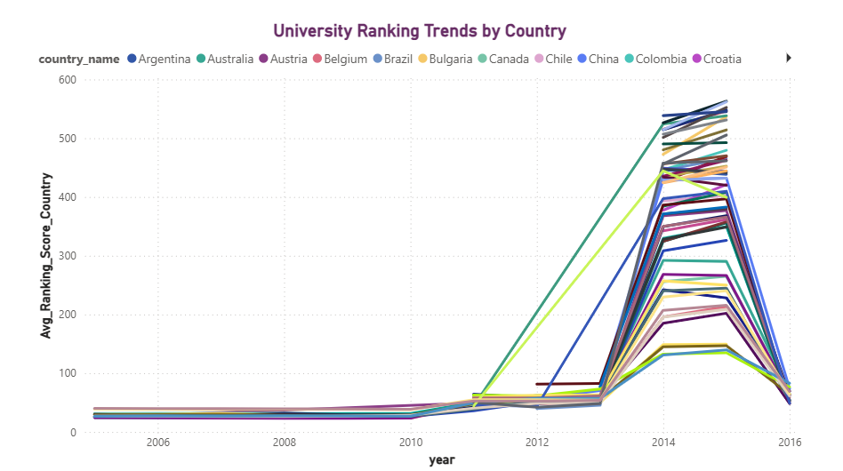

**Performance Analysis**

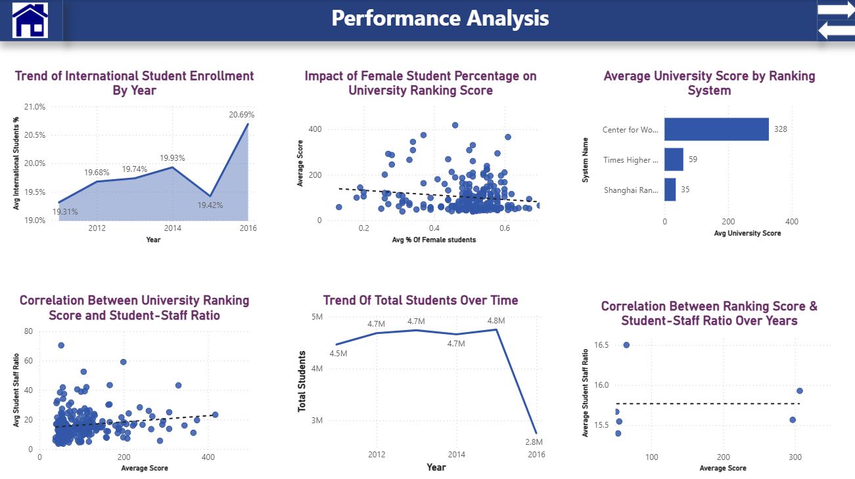

**How does the percentage of international students vary across different years?**

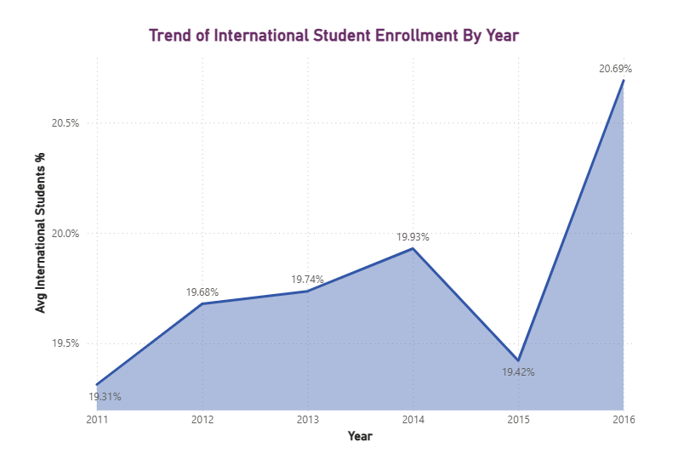The trend of international student enrolment shows a steady increase from 2011 to 2014, a slight decline in 2015, and a sharp rise in 2016, reaching its highest point. The universities are becoming more attractive to international students, possibly due to improved academic reputation, policies, or global outreach programs. However, the dip in 2015 indicates potential challenges such as policy changes, tuition hikes, or global economic factors. To maintain consistent growth, universities should enhance international student support services, offer competitive scholarships, and strengthen partnerships with global institutions to ensure long-term stability in enrolment.

**How does the percentage of female students impact a university's ranking?**

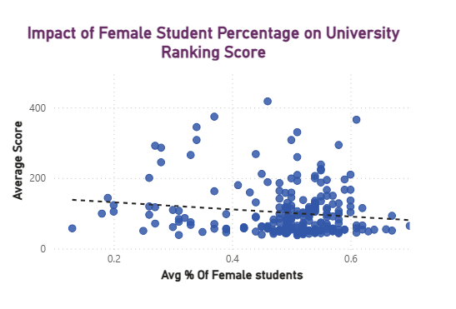The scatter plot suggests a weak negative correlation between the percentage of female students and the average university score, indicating that universities with a higher proportion of female students tend to have slightly lower scores. However, the trend is not strong enough to draw definitive conclusions, implying that other factors influence university rankings. To improve the analysis, additional variables such as faculty quality, research output, or funding should be considered. Using regression analysis or controlling for other influencing factors could provide deeper insights into the relationship between gender diversity and university performance.

**What is the average score for universities according to each ranking system?**

The visual highlights a significant disparity in average university scores across different ranking systems. The Centre for World University Rankings (CWUR) assigns much higher scores (328) compared to Times Higher Education (THE) (59) and Shanghai Rankings (35), indicating different evaluation methodologies.

This result suggests that:

Scoring systems are not standardized across ranking platforms, making direct comparisons challenging.

CWUR's scoring method might be more lenient or use a broader scale, whereas THE and Shanghai Rankings apply more stringent criteria.

The differences emphasize the need to analyse ranking methodologies before interpreting scores, as a high score in one system does not necessarily translate to a high ranking in another.

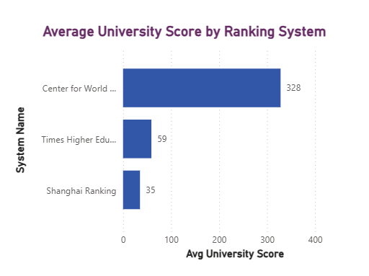Overall, the result highlights the importance of context in university rankings and the need for universities and students to consider multiple ranking systems for a comprehensive evaluation.

**Is there a correlation between a university's ranking and its student-staff ratio?**

The scatter plot shows a weak positive correlation between university ranking scores and student-staff ratios, indicating that while faculty availability impacts rankings, it is not the primary determinant. Universities with higher scores generally maintain moderate student-staff ratios, whereas mid-ranked institutions display greater variation, suggesting that factors like research output, reputation, and funding also play significant roles. To improve rankings, universities should optimize faculty-student engagement by hiring more faculty or enhancing teaching methods. Additionally, investing in research, strengthening global collaborations, and improving academic infrastructure can contribute to better student support. Increasing international partnerships can also attract global talent, enhancing diversity and academic standing. While student-staff ratio is a factor, a well-rounded approach focusing on faculty resources, research, and global engagement is essential for sustained improvement in university rankings.

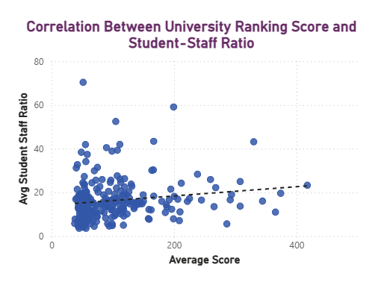

**How does the number of students in universities change over time?**

The trend indicates a steady rise in total student enrolment from 2011 to 2015, peaking at 4.7 million, followed by a dramatic drop to 2.75 million in 2016. The consistent growth until 2015 suggests a stable or improving higher education environment, possibly driven by increased accessibility, government support, or rising demand for higher education. However, the sharp decline in 2016 raises concerns about policy changes, tuition fee hikes, funding cuts, demographic shifts, or geopolitical factors that may have affected student enrolment. Such a sudden drop could also indicate data inconsistencies or changes in reporting methods.

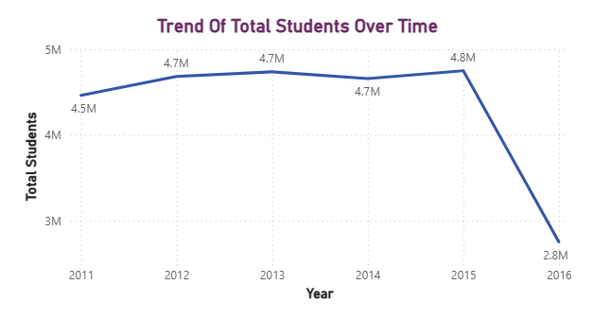To address this issue, universities and policymakers should investigate the root causes behind this decline by analysing admission policies, economic trends, and student retention rates. Strategies like scholarship programs, international student recruitment, and improving affordability can help boost enrolment and maintain stability in student numbers.

**Is there a correlation between a university's ranking score and the student-staff ratio over the years?**

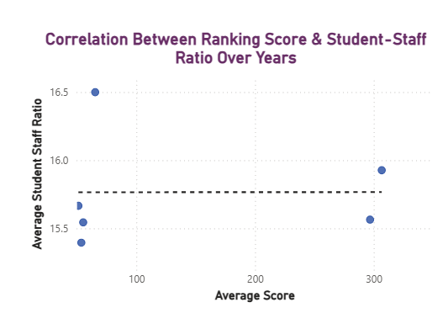The scatter plot shows a no or negligible correlation between ranking score and student-staff ratio, implying that staffing levels alone do not significantly impact university rankings. This suggests that other factors, such as research output, funding, and academic reputation, play a more crucial role. To improve rankings, universities should focus on a balanced strategy that includes enhancing faculty quality, investing in research, and improving student support services rather than solely increasing staff numbers.

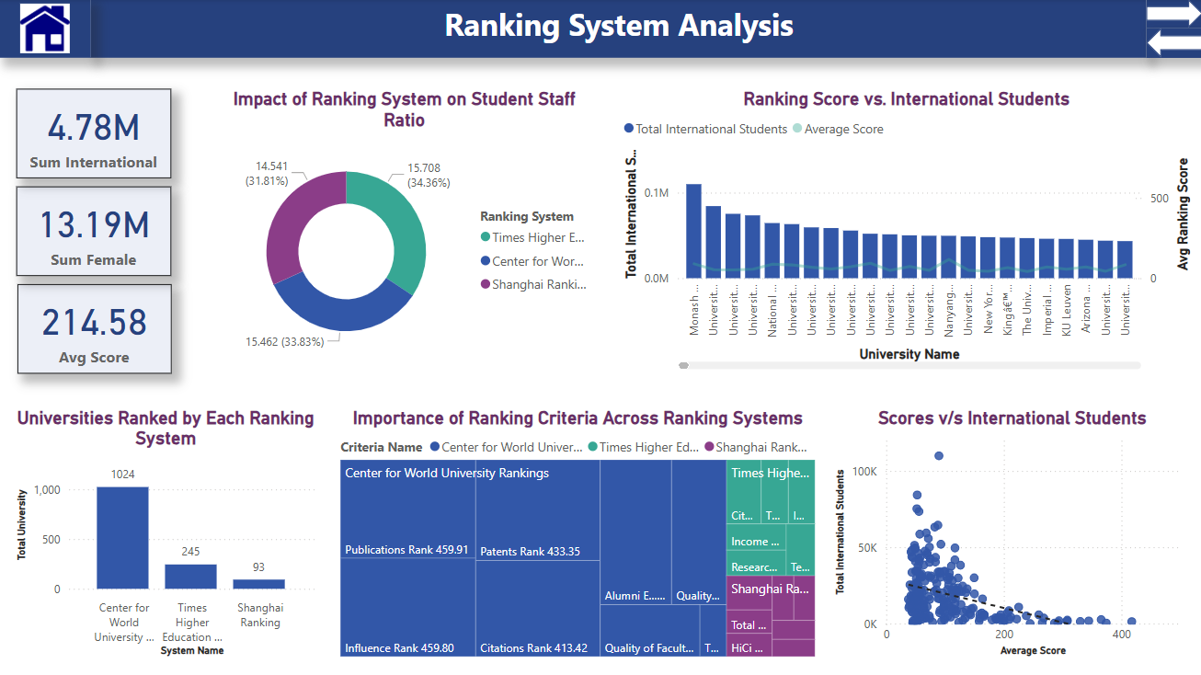**Ranking System Analysis**

**How does the ranking system affect a university's student-staff ratio?**

The Times Higher Education (THE) ranking system reports the highest average student-staff ratio (15.708), while the Shanghai Ranking (15.462) and Centre for World University Rankings (CWUR) (14.462) report slightly lower ratios. This suggests that THE ranks universities that tend to have a higher number of students per staff member, which may indicate a larger class size or fewer faculty members per student.

The slight decrease in the student-staff ratio across ranking systems implies that different methodologies may influence how student-staff ratios are considered in university rankings. Institutions with lower ratios might prioritize faculty availability and student engagement, while those with higher ratios may have larger enrolments and different faculty distribution models.

However, the impact of these differences on university rankings is unclear without additional context. Future analysis could explore whether a lower student-staff ratio correlates with higher academic performance or better student outcomes. Overall, the chart provides useful insights, but further investigation is needed to understand the broader implications of student-staff ratios in university rankings.

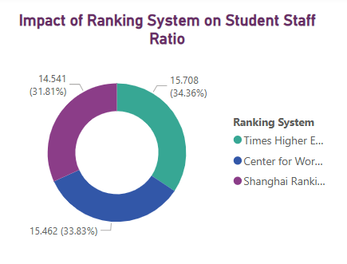

**What is the impact of a university's ranking on the number of international students it attracts?**

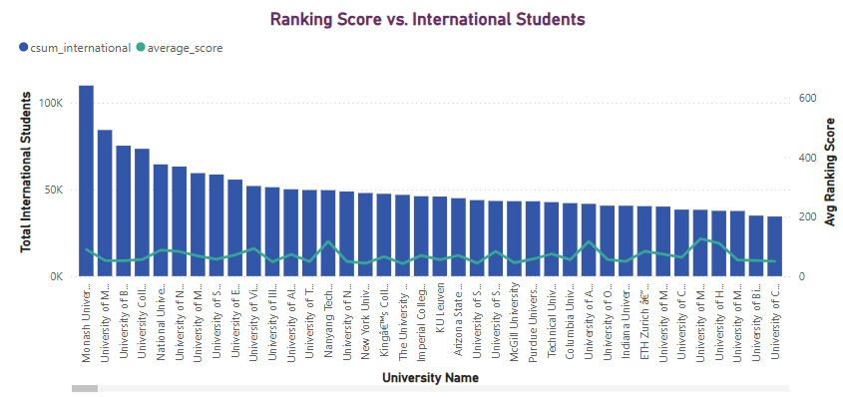The analysis reveals that while higher-ranked universities generally attract more international students, ranking alone is not the sole determining factor. Monash University, for instance, has the highest number of international students despite not having the highest Ranking score, indicating that factors such as location, tuition fees, scholarship opportunities, and student support services significantly influence international student enrolment. Additionally, the trend suggests that universities with strong global reputations and inclusive policies tend to attract more students from abroad. To enhance international student recruitment, universities should not only focus on improving rankings but also invest in factors that directly impact student experience, affordability, and academic opportunities.

**How many universities are ranked by each ranking system?**

The analysis of universities ranked by different ranking systems reveals significant variations in coverage. The Centre for World University Rankings (CWUR) ranks the highest number of universities, with 1,024 institutions included. Times Higher Education World University Ranking follows with 245 universities, while the Shanghai Ranking covers only 93 institutions. This disparity suggests that CWUR has a broader ranking approach, possibly considering more institutions worldwide, whereas Times Higher Education and Shanghai Ranking may focus on more selective or high-impact universities. Understanding these differences is crucial when interpreting university rankings and their influence on institutional reputation.

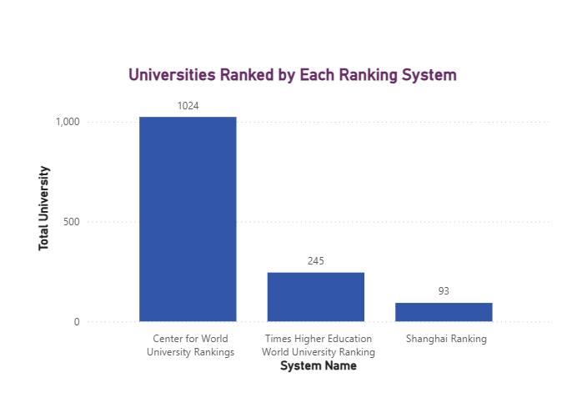

**What are the most important criteria considered by ranking systems?**

The Tree map visualization provides insights into how different university ranking systems—Centre for World University Rankings (CWUR), Times Higher Education (THE), and Shanghai Ranking—weigh various ranking criteria. CWUR places significant emphasis on research-driven metrics, such as publications (459.1), influence, Patents Rank and citations, while also considering a little bit on factors like alumni employment and education quality. THE, on the other hand, focuses more on citations, institutional income, research output, and teaching quality, indicating a balance between academic influence and institutional strength. The Shanghai Ranking prioritizes high-impact Pub (54.01), Times Higher Education focuses on citations (76.83).

This highlights how different ranking systems prioritize various criteria, meaning universities aiming to improve rankings should align their strategies accordingly.

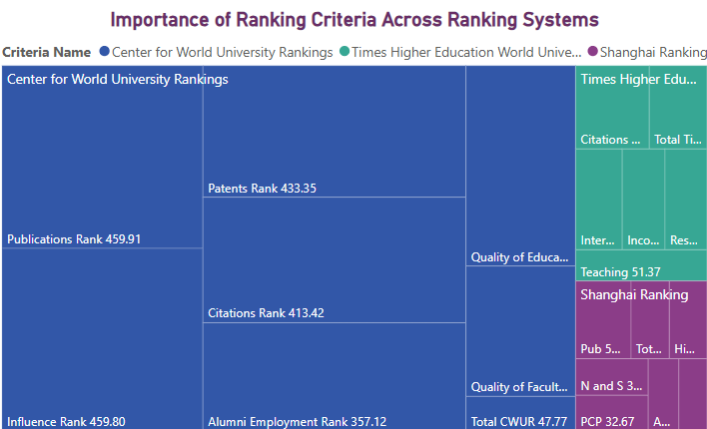

**Is there a correlation between a university's score and the number of international students?**

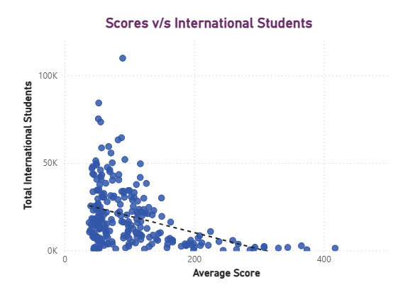The scatter plot highlights a negative correlation between university scores and the number of international students. The data points show that universities with higher scores generally have fewer international students, whereas universities with lower scores tend to attract a larger international student population. This trend suggests that highly ranked universities might have stricter admission policies, higher tuition fees, or limited seats for international students. Conversely, universities with lower scores may offer more opportunities for international students.

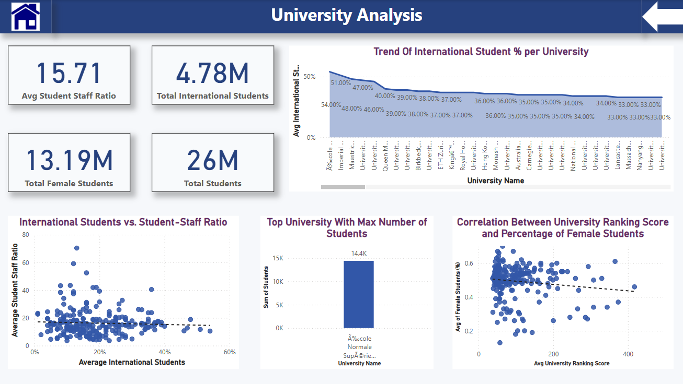**University Analysis**

**How does the percentage of international students vary across different universities?**

The analysis of international student percentage trends across universities reveals significant variations in global appeal and student diversity. The highest percentage observed is 54%, with a steady decline across institutions. Universities with the highest international student percentages, such as Imperial College and Polytechnic universities, indicate strong global recognition and favourable policies for international students. Factors such as global rankings, academic reputation, scholarship opportunities, and visa policies may contribute to this distribution. The decline in international student percentages across other universities suggests that some institutions may have limited outreach, stricter admission policies, or fewer incentives for international students. Institutions with lower percentages could improve their global attractiveness by enhancing international partnerships, offering more scholarships, and improving student support services. Understanding these trends can help universities refine their strategies to attract and retain a more diverse student body, ensuring long-term growth and competitiveness in the global education landscape.

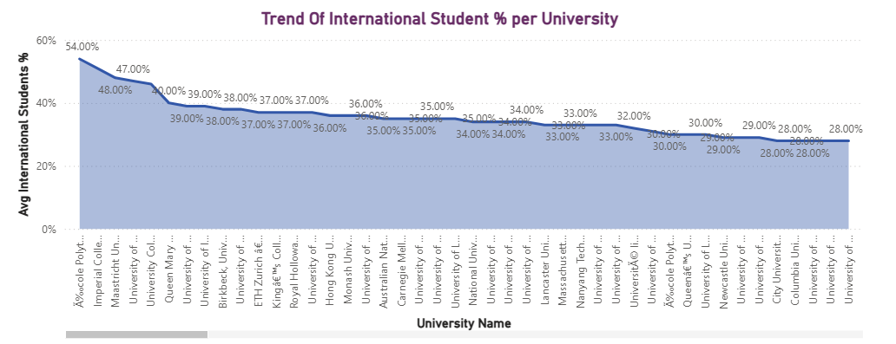

**How does the percentage of international students affect a university's student-staff ratio?**

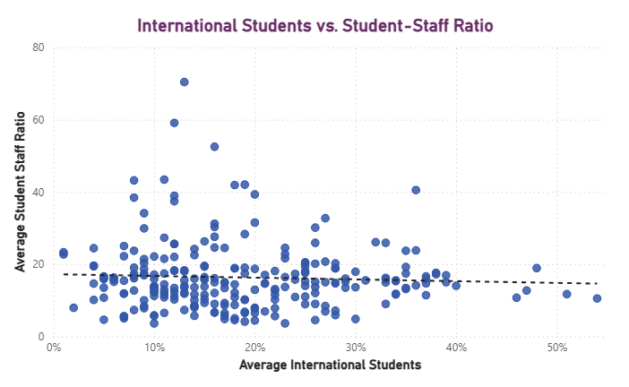The analysis indicates a weak negative correlation between international students and the student-staff ratio, suggesting that institutions with higher international enrolment may slightly improve their faculty resources. To enhance this trend, universities should invest in recruiting more faculty members and optimizing student support services to maintain educational quality while attracting international students.

**Which university has the highest number of students?**

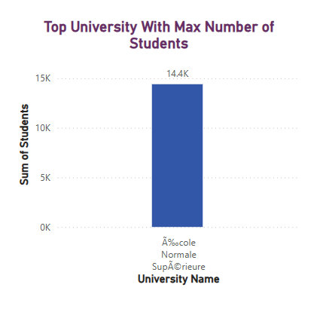The visual shows that Arizona State University has the highest number of students, totals 499,416. This indicates that it is a significantly large institution in terms of student enrolment, which may influence factors such as student diversity, resource allocation, and overall university ranking. High student numbers could also impact faculty workload, student-to-staff ratio, and infrastructure demands. Further analysis could explore how such a large student population affects the university’s performance, international student intake, and academic reputation compared to other institutions.

**Is there a relationship between a university's ranking score and the percentage of female students enrolled?**

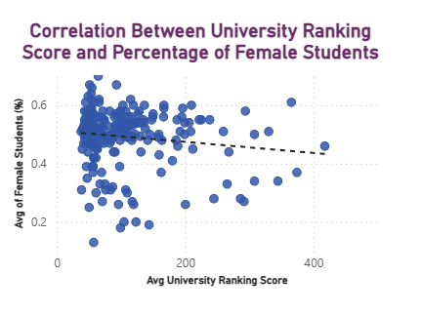The analysis indicates a slight negative correlation between university ranking scores and the percentage of female students, suggesting that higher-ranked institutions may have a lower proportion of female enrolment. This could be due to various socio-cultural or institutional factors. To promote gender diversity, universities should implement targeted scholarship programs, mentorship initiatives, and outreach efforts to encourage female participation in higher education, particularly in fields where they are underrepresented**.**

**EDA Problem Statements**

**Is there a correlation between a country's GDP and the number of universities?**

The analysis shows a positive correlation between GDP and the number of universities, indicating that wealthier countries generally have more universities due to greater investments in education. The upward trend in the scatter plot supports this relationship, though some variations suggest that factors beyond GDP, such as government policies, population size, and education priorities, also influence university numbers. Additionally, some outliers indicate that certain countries may focus more on research-intensive institutions rather than the sheer number of universities. Overall, while GDP plays a crucial role, it is not the sole determinant of 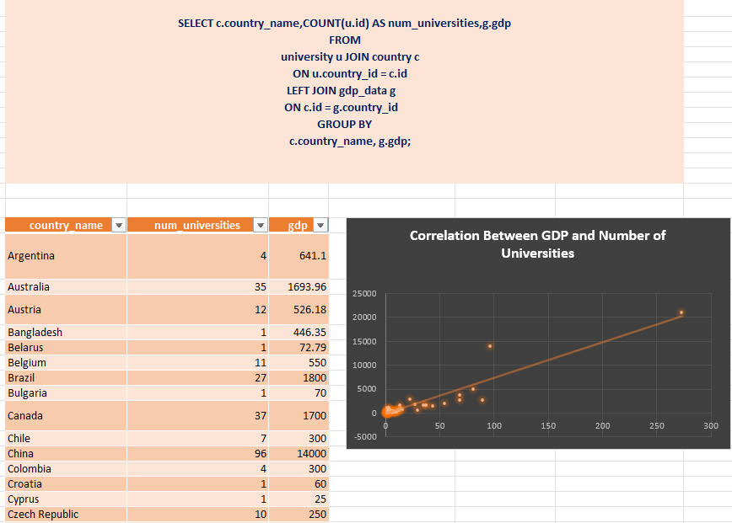university distribution.

**How has the number of universities changed over the years in each country?**

The trend analysis of universities over the years shows fluctuations in university counts across different countries. Some countries, like Belgium (yellow line), initially experienced growth but saw a significant decline after 2015, indicating possible policy changes or funding reductions. Other countries, such as Austria and Canada, show relatively stable trends, suggesting steady higher education expansion.

The presence of multiple overlapping lines at lower university counts implies that many countries have smaller but consistent numbers of universities. Overall, while some nations experienced growth, others faced declines, reflecting variations in education policies, economic conditions, and government investments in higher education.

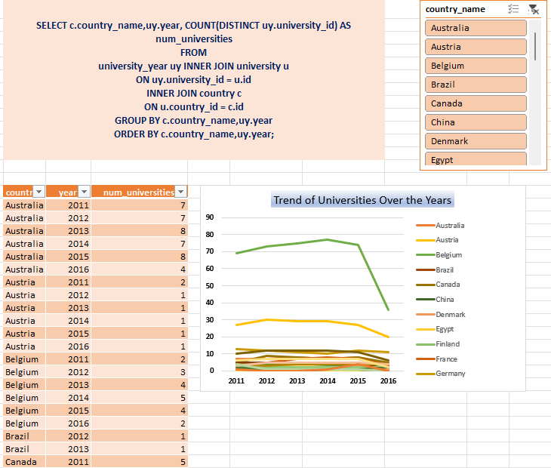

**Is there a relationship between a country's population and the number of universities?**

The analysis reveals a positive correlation between population size and the number of universities, with larger countries like China and India having significantly more universities. However, some smaller countries also show a high number of universities, indicating that national investment in education is a critical factor. To address disparities, countries with smaller populations should prioritize educational funding and infrastructure to enhance their higher education systems. Additionally, international collaborations and partnerships can help smaller nations expand their educational capabilities, ensuring broader access to quality 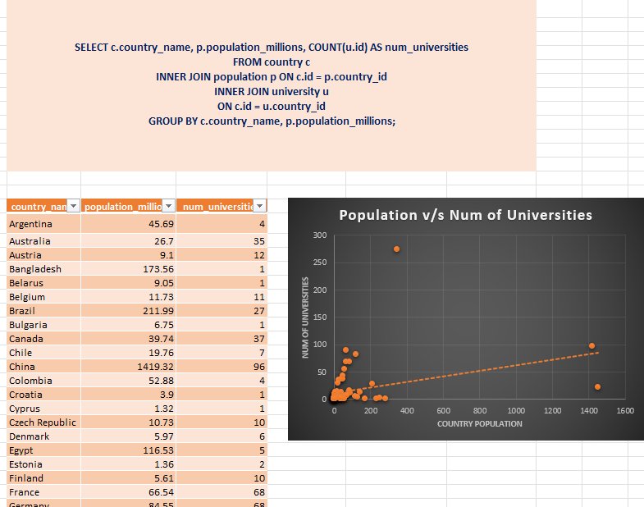education globally.

**Are there any common criteria used by different ranking systems?**

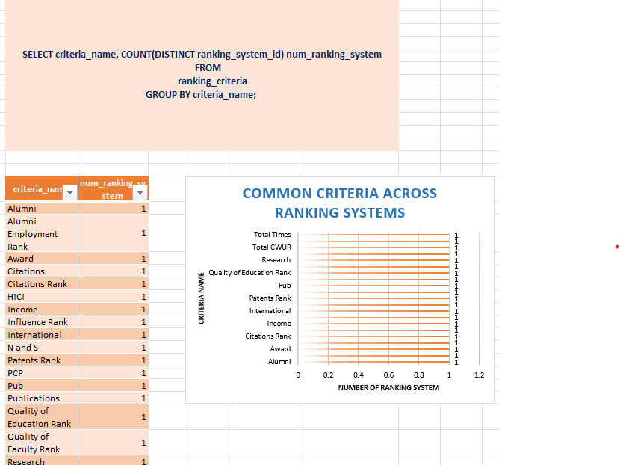The analysis reveals that different ranking systems use distinct evaluation criteria, with no common criteria shared across multiple systems. This indicates that university rankings are highly dependent on the specific ranking methodology, making direct comparisons between different ranking systems challenging. The variation in criteria, such as research output, citations, income, or alumni success, suggests that universities may rank differently depending on the system used. This highlights the importance of understanding the methodology behind each ranking system before drawing conclusions about university performance.

**What is the trend in university rankings over the years according to each system?**

The analysis highlights distinct trends in university rankings across different ranking systems over time.

The Shanghai Ranking remains stable, indicating consistency in its evaluation criteria. In contrast, the Centre for World University Rankings (CWUR) sees a sharp increase around 2013, suggesting possible changes in its scoring methodology or a shift in university performance.

The Times Higher Education World University Ranking shows a gradual rise, indicating evolving evaluation factors or improvements in universities' performance.

These differences emphasize how ranking systems adapt over time, affecting how universities are perceived globally.

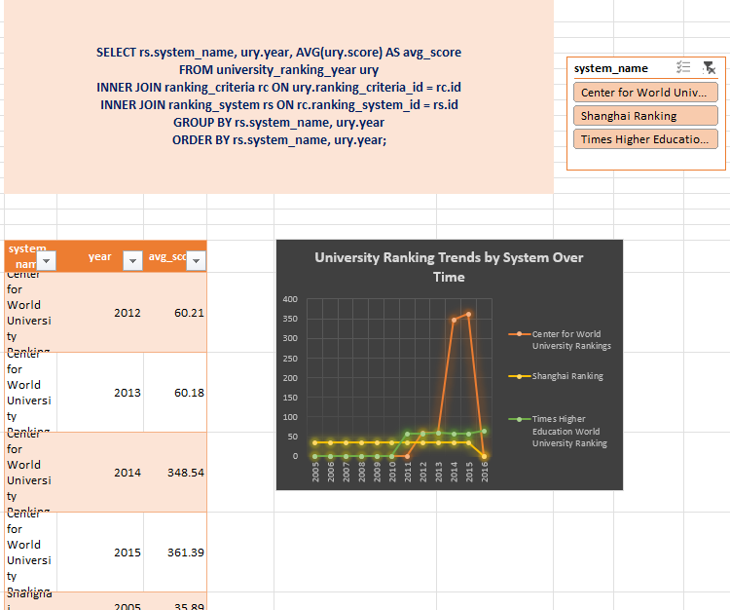

**How does the choice of ranking system affect a university's international student enrolment?**

The pie chart shows the distribution of international students across different ranking systems. The Shanghai Ranking has the highest percentage of international students (34%), followed closely by Times Higher Education (33%) and Centre for World University Rankings (33%). This indicates that international student representation is fairly balanced across ranking systems, suggesting that universities ranked in different systems attract international students at similar rates. However, slight variations might be due to differences in ranking methodologies and regional preferences.

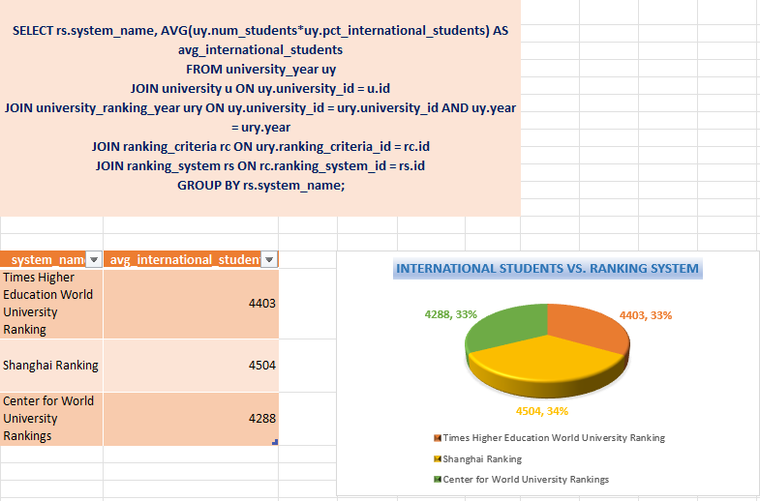**Are there any criteria that have different weights in different ranking systems?**

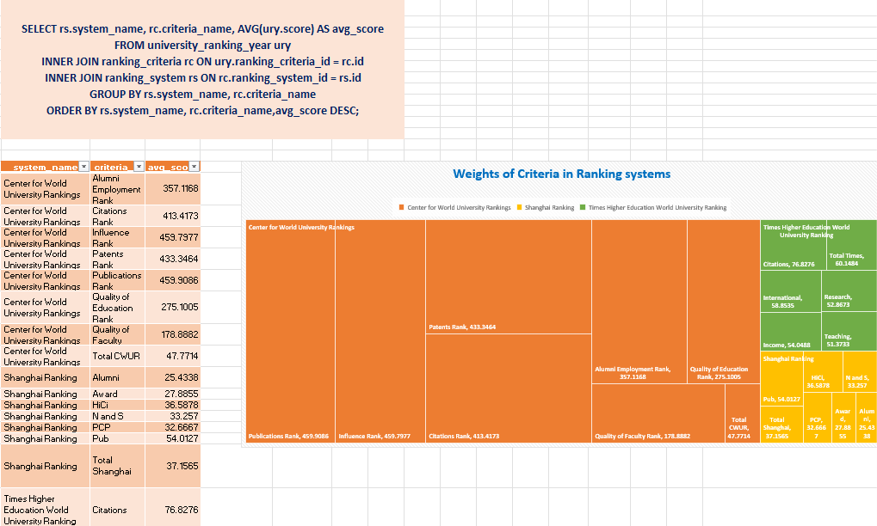The analysis highlights the growing emphasis on research output (Publications, Citations) and international factors in university rankings, while alumni-related criteria are less prioritized. To improve rankings, institutions should focus on enhancing research quality and impact, fostering international collaborations, and increasing global visibility. Additionally, maintaining strong teaching standards and institutional income can further bolster performance. By aligning strategies with these key criteria, universities can better position themselves in competitive rankings and attract top talent and funding.

**How have the weights of ranking criteria changed over time?**

The data reveals a clear shift in the weighting of ranking criteria over time, with a growing emphasis on research impact (Citations), internationalization (International), and institutional income (Income). Meanwhile, the importance of alumni-related factors (Alumni) has steadily declined. Criteria such as Awards, HiCi, and Publications have remained relatively stable, indicating their consistent relevance. Additionally, Per Capita Performance (PCP), Research, and Teaching have shown fluctuations but generally increased in importance. These trends reflect a broader prioritization of research excellence, global engagement, and financial sustainability in institutional rankings, while traditional factors like 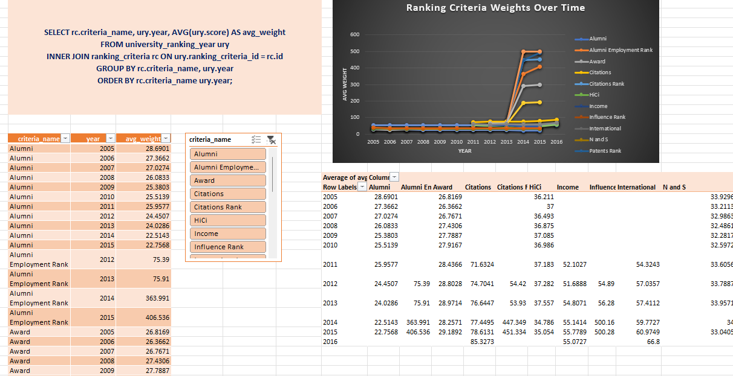alumni influence are becoming less significant.

**Is there a relationship between a university's score and the student-staff ratio?**

The analysis of the relationship between university scores and student-staff ratios reveals a weak negative correlation. Universities with lower student-staff ratios generally achieve higher scores, indicating that better faculty availability may contribute to improved academic performance. However, the spread of data points suggests that student-staff ratio alone is not a definitive factor in determining university rankings, as universities with similar ratios show varying scores. The presence of outliers further emphasizes that other ranking criteria, such as research output, funding, and international reputation, may have a more significant impact. Overall, while a lower student-staff ratio may benefit a university’s score, it is not 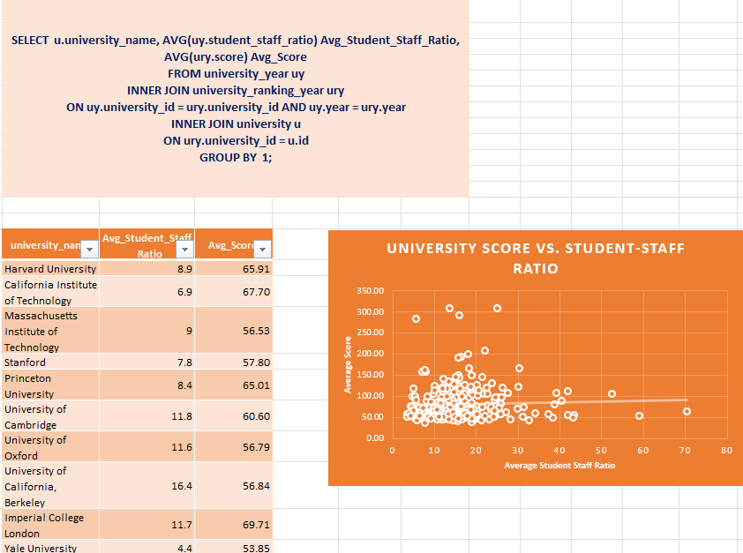the sole determinant of ranking performance.

**How does the number of female students differ among universities?**

The comparison of female student enrolment across universities shows significant variation in the number of female students enrolled. Some universities have a relatively higher average female student population, while others have a much lower representation. This suggests that factors such as university size, location, academic programs, and institutional policies may influence female enrolment rates. The presence of universities with notably high female student numbers indicates that some institutions attract a larger proportion of female students, possibly due to specialized programs or a higher overall student intake.

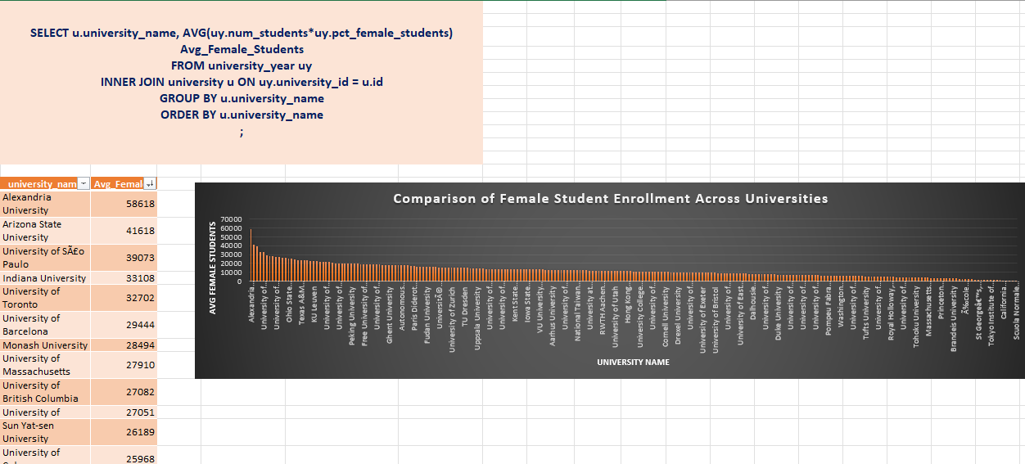

**What is the distribution of universities across different countries?**

The analysis of university distribution by country reveals a significant disparity in the number of ranked universities worldwide.

The United States leads with 273 universities, far ahead of other nations, emphasizing its dominance in global higher education. China (96), the United Kingdom (89), and Japan (81) also have a strong presence, followed by Germany and France (68 each), Italy (54), and Spain (43), highlighting Europe’s major role in academia. North America is largely represented by the U.S. and Canada (37), while Asia sees strong representation from China, Japan, and South Korea (37). Brazil (27) emerges as the leader in Latin America, while India (22) and Turkey (15) indicate growing academic influence and 11 country have only 1 universities in each.

The data suggests that established education systems in developed nations continue to dominate rankings, while emerging economies have room for expansion, underscoring the need for further investment in higher education to increase global 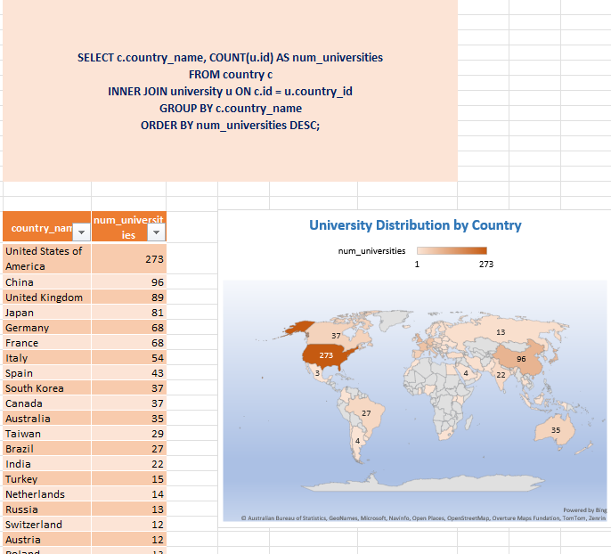representation.

**How has the ranking of universities changed over the years?**

University rankings have fluctuated significantly over the years, with some institutions improving while others declined. Alexandria University saw the highest rise, gaining 510.33 points in 2014, followed by National Sun Yat-sen University with 452.71 points. Other notable improvers include Hong Kong Baptist University and Middle East Technical University. In contrast, the University of Trento experienced the steepest decline in 2016, losing 384.08 points, along with the University of 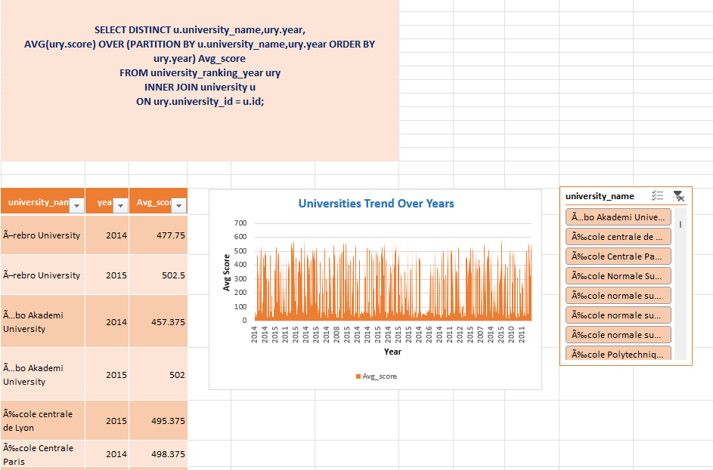Konstanz and the University of Waterloo.

Overall, university scores remained stable from 2005 to 2010 but surged in 2014-2015, peaking at 342.65 points. However, a sharp drop in 2016, with the average score falling to 65.28, suggests possible changes in ranking methodologies or stricter evaluation criteria. These trends highlight the evolving nature of university rankings.

**What is the trend in the percentage of female students over time?**

The trend of female student enrolment has remained relatively stable between 49% and 50% over the years, with a notable rise in 2012, a slight decline from 2013 to 2015, and a sharp increase in 2016. This indicates a balanced gender ratio in universities, though fluctuations suggest external influences such as policies, scholarships, or societal factors. To further support female enrolment, universities should implement targeted initiatives like mentorship programs, scholarships, and STEM-focused outreach, while also analysing the factors behind these variations to develop more 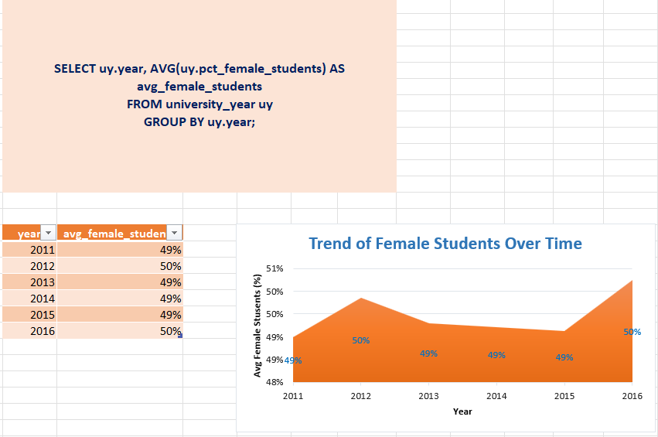effective gender equity strategies.

**How has the ranking score of universities evolved over the years?**

The trend in the average university ranking score over the years shows a consistent period of stability from 2005 to around 2012, followed by a sharp increase between 2013 and 2015. This sudden surge may indicate significant changes in university ranking methodologies, inclusion of new institutions, or improvements in certain universities' performance. However, the sharp drop in 2016 suggests a possible correction, policy shift, or changes in ranking criteria. Understanding the reasons behind these fluctuations would require a deeper investigation into ranking system adjustments or external factors affecting university 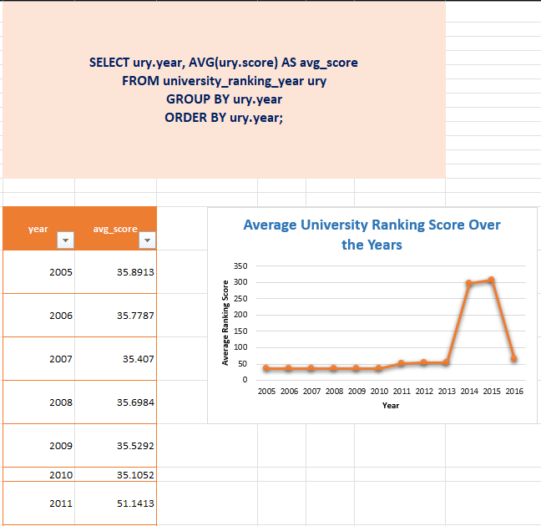scores.

**Is there a relationship between a university's ranking score and the number of students over time?**

The analysis reveals a weak negative correlation (-0.28) between ranking score and the number of students, indicating that universities with higher ranking scores tend to have fewer students. However, this relationship is not strong enough to suggest that student population alone significantly impacts rankings. Elite universities, such as Caltech, often have smaller student bodies but achieve high scores due to factors like selective admissions, strong faculty-student ratios, and research excellence. On the other hand, larger universities may have more students but slightly lower scores, potentially due to challenges in maintaining faculty interaction and research quality per capita. Despite this trend, ranking scores are influenced by multiple factors, including faculty quality, research output, international diversity, and funding. The weak correlation suggests that student numbers alone do not drive ranking performance—other institutional characteristics play a more significant role. Therefore, while highly ranked universities may generally have fewer students, improving rankings likely depends more on academic quality and institutional resources than on student population size.

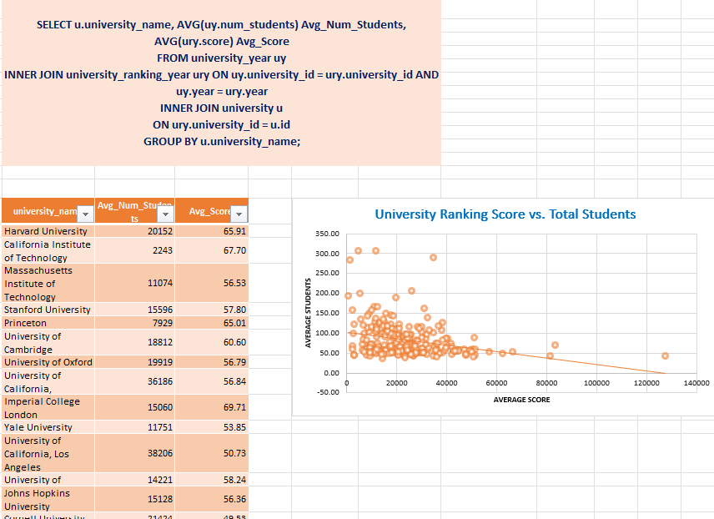

**THANK YOU**